INSTRUCTIONS FOR FILING 2024 U.S. CORPORATION INCOME TAX RETURN
April 15, 2025 SIGNATURE:
An authorized officer of the corporation should sign and date the return at the bottom of the first page.
FILING:
File your 2024 Form 1120, U.S. Corporation Income Tax Return, (or Form 1120-H, U.S. Income Tax Return for Homeowners Associations) with:
Department of the Treasury
Internal Revenue Service
Kansas City, MO 64999-0012
File your 2024 Form 1120/1120-H on or before: April 15, 2025

The IRS may treat tax returns and estimated tax payments that are lost in the mail as not filed on time, unless you send them by registered or certified mail. To avoid the risk of your tax return being lost, mail it via (1) certified U.S. mail, return receipt requested, or (2) one of the private delivery services listed in the IRS instructions under "When to File." Save the receipt, and you will be presumed to have timely filed your return - even if it is not received by the IRS.
TAX DUE OR REFUND, OVERPAYMENT, ESTIMATED TAXES:
No tax is due with your Federal income tax return.
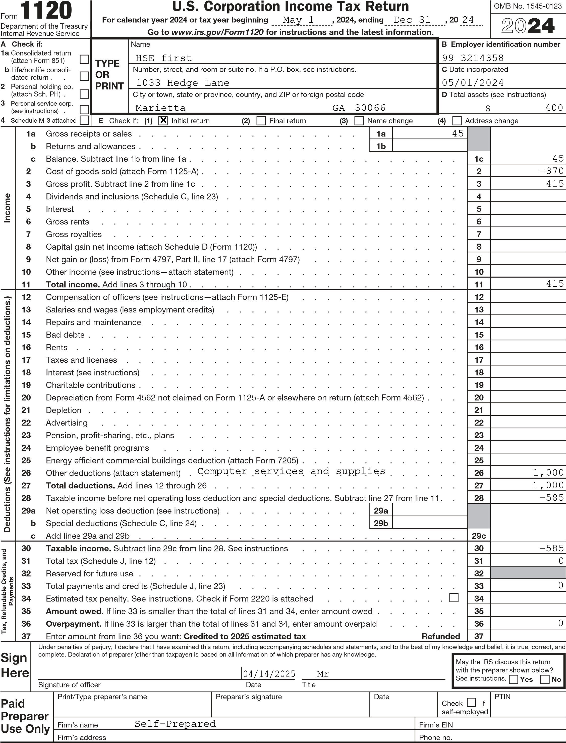
For Paperwork Reduction Act Notice, see separate instructions. REV 03/21/25 TTBIZ ^{Form} 1120 (2024)
BAA
Schedule C | Dividends, Inclusions, and Special Deductions (see instructions) | (a) Dividends and inclusions | (b) % | (c) Special deductions  (a) × (b)
- Dividends from less-than-20%-owned domestic corporations (other than debt-financed stock) . . . . . . . . . . . . . . . . . . . . . . . .  - Dividends from 20%-or-more-owned domestic corporations (other than debt-financed stock) . . . . . . . . . . . . . . . . . . . . . . . .  - Dividends on certain debt-financed stock of domestic and foreign corporations . .  - Dividends on certain preferred stock of less-than-20%-owned public utilities . . .  - Dividends on certain preferred stock of 20%-or-more-owned public utilities . . . .  - Dividends from less-than-20%-owned foreign corporations and certain FSCs . . .  - Dividends from 20%-or-more-owned foreign corporations and certain FSCs . . .  - Dividends from wholly owned foreign subsidiaries . . . . . . . . . . .  - Subtotal. Add lines 1 through 8. See instructions for limitations . . . . . . .  - Dividends from domestic corporations received by a small business investment company operating under the Small Business Investment Act of 1958 . . . . .  - Dividends from affiliated group members . . . . . . . . . . . . . .  - Dividends from certain FSCs . . . . . . . . . . . . . . . . .  - Foreign-source portion of dividends received from a specified 10%-owned foreign corporation (excluding hybrid dividends) (see instructions) . . . . . . . . .  - Dividends from foreign corporations not included on line 3, 6, 7, 8, 11, 12, or 13  (including any hybrid dividends) . . . . . . . . . . . . . . . . .  - Reserved for future use . . . . . . . . . . . . . . . . . . .  16a Subpart F inclusions derived from the sale by a controlled foreign corporation (CFC) of the stock of a lower-tier foreign corporation treated as a dividend (attach Form(s) 5471)  (see instructions) . . . . . . . . . . . . . . . . . . . . .  - Subpart F inclusions derived from hybrid dividends of tiered corporations (attach Form(s)  5471) (see instructions) . . . . . . . . . . . . . . . . . . .  - Other inclusions from CFCs under subpart F not included on line 16a, 16b, or 17 (attach  Form(s) 5471) (see instructions) . . . . . . . . . . . . . . . . .  - Global Intangible Low-Taxed Income (GILTI) (attach Form(s) 5471 and Form 8992) . .  - Gross-up for foreign taxes deemed paid . . . . . . . . . . . . . .  - IC-DISC and former DISC dividends not included on line 1, 2, or 3 . . . . . .  - Other dividends . . . . . . . . . . . . . . . . . . . . .  - Deduction for dividends paid on certain preferred stock of public utilities . . . .  - Section 250 deduction (attach Form 8993) . . . . . . . . . . . . .  - Total dividends and inclusions. Add column (a), lines 9 through 20. Enter here and on page 1, line 4 . . . . . . . . . . . . . . . . . . . . . .  - Total special deductions. Add column (c), lines 9 through 22. Enter here and on page 1, line 29b |  |  | 50
 |  |  | 65
 |  |  | See instructions
 |  |  | 23.3
 |  |  | 26.7
 |  |  | 50
 |  |  | 65
 |  |  | 100
 |  |  | See instructions
 |  |  | 100
 |  |  | 100
 |  |  | 100
 |  |  | 100
 |  |  | 100
 |  | . . . . . . .
REV 03/21/25 TTBIZ Form 1120 (2024)

Schedule J | Tax Computation and Payment (see instructions)
- a Income tax (see instructions) . . . . . . . . . . . . . . . . . . b Tax from Form 1120-L (see instructions) . . . . . . . . . . . . . . c Section 1291 tax from Form 8621 . . . . . . . . . . . . . . . . d Tax adjustment from Form 8978 . . . . . . . . . . . . . . . . . e Additional tax under section 197(f) . . . . . . . . . . . . . . . . f Base erosion minimum tax from Form 8991 . . . . . . . . . . . . . g Amount from Form 4255, Part I, line 3, column (q) . . . . . . . . . . . z Other chapter 1 tax . . . . . . . . . . . . . . . . . . . .  - Total income tax. Add lines 1a through 1z . . . . . . . . . . . . . . .  - Corporate alternative minimum tax from Form 4626, Part II, line 13 (attach Form 4626). .  - Add lines 2 and 3 . . . . . . . . . . . . . . . . . . . . . .  - a Foreign tax credit (attach Form 1118) . . . . . . . . . . . . . . . b Credit from Form 8834 (see instructions) . . . . . . . . . . . . . . c General business credit (see instructions—attach Form 3800) . . . . . . . . d Credit for prior year minimum tax (attach Form 8827) . . . . . . . . . . e Bond credits from Form 8912 . . . . . . . . . . . . . . . . .  f Adjustment from Form 8978 . . . . . . . . . . . . . . . . . .  - Total credits. Add lines 5a through 5f . . . . . . . . . . . . . . . .  - Subtract line 6 from line 4 . . . . . . . . . . . . . . . . . . .  - Personal holding company tax (attach Schedule PH (Form 1120)) . . . . . . . .  - a Amount from Form 4255, Part I, line 3, column (r) . . . . . . . . . . . b Recapture of low-income housing credit (attach Form 8611) . . . . . . . . c Completed long-term contract look-back interest due (attach Form 8697) . . . . d Interest due under the look-back method—income forecast method (attach Form 8866) e Alternative tax on qualifying shipping activities (attach Form 8902) . . . . . . f Interest/tax due under section 453A(c) . . . . . . . . . . . . . . . g Interest/tax due under section 453(l) . . . . . . . . . . . . . . .  z Other (see instructions—attach statement) . . . . . . . . . . . . .  - Total. Add lines 9a through 9z . . . . . . . . . . . . . . . . . .  - a Total tax before deferred taxes. Add lines 7, 8, and 10 . . . . . . . . . .  b Deferred tax on the corporation's share of undistributed earnings of a qualified electing fund . . . . . . . . . . . . . . . . . . . . . . . . . c Deferred LIFO recapture tax (section 1363(d)) . . . . . . . . . . . .  - Total tax. Subtract the sum of lines 11b and 11c from 11a. Enter here and on page 1, line  - Preceding year’s overpayment credited to the current year . . . . . . . . . .  - Current year’s estimated tax payments . . . . . . . . . . . . . . .  - Current year’s refund applied for on Form 4466 . . . . . . . . . . . . .  - Reserved for future use . . . . . . . . . . . . . . . . . . . .  - Tax deposited with Form 7004 . . . . . . . . . . . . . . . . . .  - Withholding (see instructions) . . . . . . . . . . . . . . . . . .  - Total payments. Combine lines 13 through 18 . . . . . . . . . . . . .  - Refundable credits from: a Form 2439 . . . . . . . . . . . . . . . . . . . . . . . b Form 4136 . . . . . . . . . . . . . . . . . . . . . . .  c Credit for tax withheld under chapter 3 or 4 from Form 1042-S, Form 8805, or Form  8288 (attach the applicable form) . . . . . . . . . . . . . . . . z Other (attach statement—see instructions) . . . . . . . . . . . . .  - Total credits. Add lines 20a through 20z . . . . . . . . . . . . . . .  - Elective payment election amount from Form 3800 . . . . . . . . . . . .  - Total payments and credits. Add lines 19, 21, and 22. Enter here and on page 1, line 33. |  | 1a |  |  |  |  | 0 |  | 0
 |  | 1b |  |  |  |  |  |  | 0
 |  | 1c |  |  |  |  |  |  | 0
 |  | 1d |  |  |  |  |  |  | 0
 |  | 1e |  |  |  |  |  |  | 0
 |  | 1f |  |  |  |  |  |  | 0
 |  | 1g |  |  |  |  |  |  | 0
 |  | 1z |  |  |  |  |  |  | 0
 |  | . .  . .  . .  5a | .  .  . | .  .  . | .  .  . | .  .  . | .  .  . | 2 | 0
 |  |  |  |  |  |  |  | 3
 |  |  |  |  |  |  |  | 4 | 0
 |  | 5b
 |  | 5c
 |  | 5d
 |  | 5e
 |  | 5f
 |  | . .  . .  . .  9a | .  .  . | .  .  . | .  .  . | .  .  . | .  .  . | 6
 |  |  |  |  |  |  |  | 7 | 0
 |  |  |  |  |  |  |  | 8
 |  | 9b
 |  | 9c
 |  | 9d
 |  | 9e
 |  | 9f
 |  | 9g
 |  | 9z
 |  | . .  11a | . | . | . | . | .  0 | 10
 |  |  |  |  |  |  |  |  | 0
 |  | 11b |  |  |  |  |  |  | 0
 |  | 11c |  |  |  |  |  |  | 0
 |  | 31 . .  . .  . .  . .  . .  . .  . .  . .  20a | .  .  .  .  .  .  .  . | .  .  .  .  .  .  .  . | .  .  .  .  .  .  .  . | .  .  .  .  .  .  .  . | .  .  .  .  .  .  .  . | 12 | 0
 |  |  |  |  |  |  |  | 13
 |  |  |  |  |  |  |  | 14 | 0
 |  |  |  |  |  |  |  | 15 | ( )
 |  |  |  |  |  |  |  | 16
 |  |  |  |  |  |  |  | 17
 |  |  |  |  |  |  |  | 18
 |  |  |  |  |  |  |  | 19 | 0
 |  | 20b
 |  | 20c
 |  | 20z
 |  | . .  . .  . . | .  .  . | .  .  . | .  .  . | .  .  . | .  .  . | 21
 |  |  |  |  |  |  |  | 22
 |  |  |  |  |  |  |  | 23 | 0
REV 03/21/25 TTBIZ ^{Form} 1120 (2024)
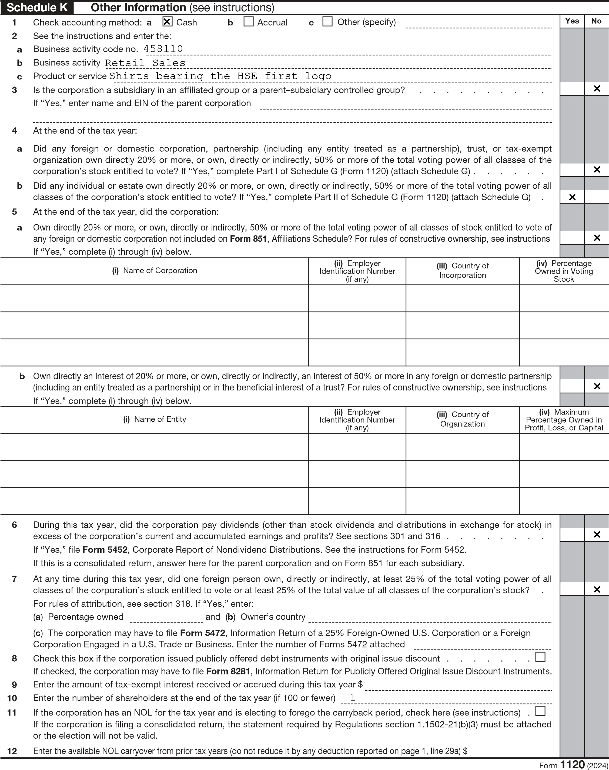
REV 03/21/25 TTBIZ
Schedule K | Other Information (continued from page 4)
- Are the corporation’s total receipts (page 1, line 1a, plus lines 4 through 10) for the tax year and its total assets at the end of the tax year less than $250,000? . . . . . . . . . . . . . . . . . . . . . . . . . . . .  If “Yes,” the corporation is not required to complete Schedules L, M-1, and M-2. Instead, enter the total amount of cash distributions and the book value of property distributions (other than cash) made during this tax year $0.  - Is the corporation required to file Schedule UTP (Form 1120), Uncertain Tax Position Statement? See instructions . . . .  If “Yes,” complete and attach Schedule UTP.  15a Did the corporation make any payments that would require it to file Form(s) 1099? . . . . . . . . . . . . . . b If “Yes,” did or will the corporation file required Form(s) 1099? . . . . . . . . . . . . . . . . . . . .  - During this tax year, did the corporation have an 80%-or-more change in ownership, including a change due to redemption of its own stock? . . . . . . . . . . . . . . . . . . . . . . . . . . . . . . . . . .  - During or subsequent to this tax year, but before the filing of this return, did the corporation dispose of more than 65% (by value) of its assets in a taxable, non-taxable, or tax deferred transaction? . . . . . . . . . . . . . . . .  - Did this corporation receive assets in a section 351 transfer in which any of the transferred assets had a fair market basis or fair market value of more than $1 million? . . . . . . . . . . . . . . . . . . . . . . . . . .  - During this corporation’s tax year, did the corporation make any payments that would require it to file Forms 1042 and 1042-S under chapter 3 (sections 1441 through 1464) or chapter 4 (sections 1471 through 1474) of the Code? . . . . . . . .  - Is the corporation operating on a cooperative basis? . . . . . . . . . . . . . . . . . . . . . .  - During this tax year, did the corporation pay or accrue any interest or royalty for which the deduction is not allowed under section 267A? See instructions . . . . . . . . . . . . . . . . . . . . . . . . . . . . .  If “Yes,” enter the total amount of the disallowed deductions $  - Does this corporation have gross receipts of at least $500 million in any of the 3 preceding tax years? (See sections 59A(e)(2) and (3).) If “Yes,” complete and attach Form 8991.  - Did the corporation have an election under section 163(j) for any real property trade or business or any farming business in effect during this tax year? See instructions . . . . . . . . . . . . . . . . . . . . . . . . .  - Does the corporation satisfy one or more of the following? If “Yes,” complete and attach Form 8990. See instructions . . . a The corporation owns a pass-through entity with current, or prior year carryover, excess business interest expense.  - The corporation’s aggregate average annual gross receipts (determined under section 448(c)) for the 3 tax years preceding the current tax year are more than $30 million and the corporation has business interest expense.  - The corporation is a tax shelter and the corporation has business interest expense.  - Is the corporation attaching Form 8996 to certify as a Qualified Opportunity Fund? . . . . . . . . . . . . .  If “Yes,” enter amount from Form 8996, line 15 . . . . . . . . . . . $  - Since December 22, 2017, did a foreign corporation directly or indirectly acquire substantially all of the properties held directly or indirectly by the corporation, and was the ownership percentage (by vote or value) for purposes of section 7874 greater than  50% (for example, the shareholders held more than 50% of the stock of the foreign corporation)? If “Yes,” list the ownership percentage by vote and by value. See instructions . . . . . . . . . . . . . . . . . . . . . . .  Percentage: By Vote By Value  - At any time during this tax year, did the corporation (a) receive a digital asset (as a reward, award, or payment for property or services); or (b) sell, exchange, or otherwise dispose of a digital asset (or a financial interest in a digital asset)? See instructions .  - Is the corporation a member of a controlled group? . . . . . . . . . . . . . . . . . . . . . . .  If “Yes,” attach Schedule O (Form 1120). See instructions.  - Corporate Alternative Minimum Tax:  - Was the corporation an applicable corporation under section 59(k)(1) in any prior tax year? . . . . . . . . . . .  If “Yes,” go to question 29b. If “No,” skip to question 29c.  - Is the corporation an applicable corporation under section 59(k)(1) in the current tax year because the corporation was an applicable corporation in the prior tax year? . . . . . . . . . . . . . . . . . . . . . . . . .  If “Yes,” complete and attach Form 4626. If “No,” continue to question 29c.  - Does the corporation meet the requirements of the safe harbor method as provided under section 59(k)(3)(A) for the current tax year? See instructions . . . . . . . . . . . . . . . . . . . . . . . . . . . . . . .  If “No,” complete and attach Form 4626. If “Yes,” the corporation is not required to file Form 4626.  30 Is the corporation required to file Form 7208 relating to the excise tax on repurchase of corporate stock (see instructions):  a Under the rules for stock repurchased by a covered corporation (or stock acquired by its specified affiliate)? . . . . . . b Under the applicable foreign corporation rules? . . . . . . . . . . . . . . . . . . . . . . . . c Under the covered surrogate foreign corporation rules? . . . . . . . . . . . . . . . . . . . . . .  If “Yes” to either 30a, 30b, or 30c, complete Form 7208, Excise Tax on Repurchase of Corporate Stock. See the Instructions for Form 7208.  31 Is this a consolidated return with gross receipts or sales of $1 billion or more and a subchapter K basis adjustment, as described in the instructions, of $10 million or more? . . . . . . . . . . . . . . . . . . . . . .  If “Yes,” attach a statement. See instructions. |  | Yes | No
Form 1120 (2024)
REV 03/21/25 TTBIZ
Schedule L | Balance Sheets per Books |  | Beginning of tax year |  | End of tax year
Assets  1 Cash . . . . . . . . . . . .  2a Trade notes and accounts receivable . . . b Less allowance for bad debts . . . . .  - Inventories . . . . . . . . . . .  - U.S. government obligations . . . . .  - Tax-exempt securities (see instructions) . .  - Other current assets (attach statement) . .  - Loans to shareholders . . . . . . .  - Mortgage and real estate loans . . . . .  - Other investments (attach statement) . . . 10a Buildings and other depreciable assets . . b Less accumulated depreciation . . . . .  11a Depletable assets . . . . . . . . . b Less accumulated depletion . . . . . . 12 Land (net of any amortization) . . . . . 13a Intangible assets (amortizable only) . . . b Less accumulated amortization . . . . . 14 Other assets (attach statement) . . . . .  15 Total assets . . . . . . . . . . |  |  | (a) | (b) | (c) | (d)
 |  |  |  |  |  | 0.
 |  |  | ( ) |  | ( )
 |  |  |  |  |  | 400.
 |  |  |  |  | 0.
 |  |  | ( ) |  | ( 0. ) | 0.
 |  |  | ( ) |  | ( )
 |  |  |  |  |  | 0.
 |  |  |  |  | 0.
 |  |  | ( ) |  | ( 0. ) | 0.
 |  |  |  |  |  | 400.
Liabilities and Shareholders’ Equity
- Accounts payable . . . . . . . . .
- Mortgages, notes, bonds payable in less than 1 year 18 Other current liabilities (attach statement) . .
- Loans from shareholders . . . . . . .
- Mortgages, notes, bonds payable in 1 year or more 21 Other liabilities (attach statement) . . . .
22 Capital stock: a Preferred stock . . . .
b Common stock . . . . 23 Additional paid-in capital . . . . . . .
24 Retained earnings—Appropriated (attach statement) 25 Retained earnings—Unappropriated . . .
- Adjustments to shareholders’ equity (attach statement)
- Less cost of treasury stock . . . . . .
- Total liabilities and shareholders’ equity . .
 |  |  |  |  | 0.
 |  |  |  |  | 0. | 0.
 |  |  |  |  |  | 0.
 |  |  |  |  |  | 0.
 |  |  |  | ( ) |  | ( 0. )
 |  |  |  |  |  | 0.
Schedule M-1 |  | Reconciliation of Income (Loss) per Books With Income per Return
Note: The corporation may be required to file Schedule M-3. See instructions.
- Net income (loss) per books . . . . . .  - Federal income tax per books . . . . .  - Excess of capital losses over capital gains .  - Income subject to tax not recorded on books this year (itemize):  - Expenses recorded on books this year not deducted on this return (itemize): a Depreciation . . . . $ b Charitable contributions . $ c Travel and entertainment . $  See Statement  - Add lines 1 through 5 . . . . . . . . |  | 0. | - Income recorded on books this year not included on this return (itemize):  Tax-exempt interest $  - Deductions on this return not charged against book income this year (itemize):  a  Depreciation  .  .  $  b  Charitable contributions  $  - Add lines 7 and 8 . . . . . .  - Income (page 1, line 28)—line 6 less line 9
 |  | 0.
 |  | 0.
 |  | 0. |  | 0.
Schedule M-2 | Analysis of Unappropriated Retained Earnings per Books (Schedule L, Line 25)
- Balance at beginning of year . . . . .  - Net income (loss) per books . . . . . .  - Other increases (itemize):  - Add lines 1, 2, and 3 . . . . . . . . |  |  | - Distributions: a Cash . . . . .  b Stock . . . . c Property . . . .  - Other decreases (itemize):  - Add lines 5 and 6 . . . . . .  - Balance at end of year (line 4 less line 7)
 |  | 0.
 |  | 0. |  | 0.
REV 03/21/25 TTBIZ ^{Form} 1120 (2024)

Form 1125-A  (Rev. November 2024)  Department of the Treasury  Internal Revenue Service | Cost of Goods Sold  Attach to Form 1120, 1120-C, 1120-F, 1120S, or 1065.  Go to www.irs.gov/Form1125A for the latest information. |  |  | OMB No. 1545-0123
Name |  | Employer identification number
HSE first |  | 99-3214358
- Inventory at beginning of year . . . . . . . . . . . . . . . . . . . . . . . . .  - Purchases . . . . . . . . . . . . . . . . . . . . . . . . . . . . . . .  - Cost of labor . . . . . . . . . . . . . . . . . . . . . . . . . . . . . .  - Additional section 263A costs (attach schedule) . . . . . . . . . . . . . . . . . . . .  - Other costs (attach schedule) . . . . . . . . . . . . . . . . . . . . . . . . .  - Total. Add lines 1 through 5 . . . . . . . . . . . . . . . . . . . . . . . . . . 7 Inventory at end of year . . . . . . . . . . . . . . . . . . . . . . . . . . .  8 Cost of goods sold. Subtract line 7 from line 6. Enter here and on Form 1120, page 1, line 2, or the appropriate line of your tax return. See instructions . . . . . . . . . . . . . . . . . . . . . . |  |  | 1
 |  |  | 2 |  | 30
 |  |  | 3
 |  |  | 4
 |  |  | 5
 |  |  | 6 |  | 30
 |  |  | 7 |  | 400
 |  |  | 8 |  | -370
9a Check all methods used for valuing closing inventory. See instructions.
(i)Cost
(ii)Lower of cost or market
(iii)Other (specify method used and attach explanation)
For certain small business taxpayers, alternative methods of accounting for inventories:
(iv)Non-incidental materials and supplies method
(v)AFS method
(vi)Non-AFS method
9d(i)
9d(ii)
b Check if there was a writedown of subnormal goods . . . . . . . . . . . . . . . . . . . . . . . c Check if the LIFO inventory method was adopted this tax year for any goods (if checked, attach Form 970) . . . . . . . d (i) If the LIFO inventory method was used for this tax year, enter amount of closing inventory figured under LIFO (ii) If the LIFO inventory method was used for this tax year, enter amount of the closing LIFO Reserve . . . .
- If property is produced or acquired for resale, do the rules of section 263A apply to the entity? See instructions . . Yes No
- Was there any change in determining quantities, cost, or valuations between opening and closing inventory? If “Yes,”
attach explanation . . . . . . . . . . . . . . . . . . . . . . . . . . . . . Yes No

Section references are to the Internal Revenue Code unless otherwise noted.

What’s New
Small business taxpayers. For tax years beginning after December 31, 2023, if filing Form 1125-A for a small business taxpayer that uses an alternative method of accounting for inventories, check the applicable box on line 9a(iv) through 9a(vi). See the instructions for line 9.
General Instructions

Purpose of Form
Use Form 1125-A to figure and deduct cost of goods sold for certain entities.

Who Must File
Filers of Form 1120, 1120-C, 1120-F,
1120S, or 1065 must complete and attach Form 1125-A if the applicable entity reports a deduction for cost of goods sold.

Inventories
Generally, inventories are required at the beginning and end of each tax year if the production, purchase, or sale of merchandise is an income-producing factor. See Regulations section 1.471-1(a).
If inventories are required, you generally must use an accrual method of accounting for sales and purchases of inventory items.
Exception for small business taxpayers. A small business taxpayer can account for inventory by treating the inventory as non-incidental materials and supplies (line 9a(iv)), or conforming to its treatment of inventory in an applicable financial statement (as defined in section 451(b)(3)) (line 9a(v)). If it does not have an applicable financial statement, a small business taxpayer can use the method of accounting used in its books and records prepared according to its accounting procedures
(line 9a(vi)).
See the discussion on small business taxpayers in the instructions for your tax return. Also see sections 448(c) and 471(c).
For additional guidance on methods of accounting, see Pub. 538, Accounting Periods and Methods. For guidance on changing methods of accounting, see Form 3115, Application for Change in Accounting Method, and the Instructions for Form 3115.
Uniform capitalization rules. The uniform capitalization rules of section 263A generally require you to capitalize, or include in inventory, certain costs incurred in connection with the following.
- The production of real property and tangible personal property held in inventory or held for sale in the ordinary course of business.
- Real property or personal property (tangible and intangible) acquired for resale.
- The production of real property and tangible personal property for use in its trade or business or in an activity engaged in for profit.
A small business taxpayer is not required to capitalize costs under section 263A. See section 263A(i).
See the discussion on section 263A uniform capitalization rules in the instructions for your tax return before completing Form 1125-A. Also see Regulations sections 1.263A-1 through
1.263A-3. See Regulations section 1.263A-4 for rules for property produced in a farming business and Pub. 225, Farmer’s Tax Guide.

For Paperwork Reduction Act Notice, see instructions.BAA Cat. No. 55988R REV 03/21/25 TTBIZ ^{Form} 1125-A (Rev. 11-2024)
SCHEDULE G  (Form 1120)  (Rev. December 2011)  Department of the Treasury  Internal Revenue Service |  | Information on Certain Persons Owning the Corporation’s Voting Stock  a Attach to Form 1120. a See instructions on page 2. |  | OMB No. 1545-0123
Name |  |  | Employer identification number (EIN)
HSE first |  |  | 99-3214358
Part I | Certain Entities Owning the Corporation’s Voting Stock. (Form 1120, Schedule K, Question 4a). Complete
columns (i) through (v) below for any foreign or domestic corporation, partnership (including any entity treated as a partnership), trust, or tax-exempt organization that owns directly 20% or more, or owns, directly or indirectly, 50% or more of the total voting power of all classes of the corporation’s stock entitled to vote (see instructions).
Certain Individuals and Estates Owning the Corporation’s Voting Stock. (Form 1120, Schedule K, Question 4b). Complete columns (i) through (iv) below for any individual or estate that owns directly 20% or more, or owns, directly or indirectly, 50% or more of the total voting power of all classes of the corporation’s stock entitled to vote (see instructions).
i) Name of Entity
(
ii) Employer Identification
(
Number (if any)
iii) Type of Entity
(
iv) Country of Organization
(
v) Percentage Owned in Voting Stock
(
Part II
(i) Name of Individual or Estate | (ii) Identifying Number  (if any) | (iii) Country of  Citizenship (see instructions) | (iv) Percentage Owned in Voting Stock
Peter Parsons | 99-3214358 | US | 100
For Paperwork Reduction Act Notice, REV 03/21/25 TTBIZ Schedule G (Form 1120) (Rev. 12-2011) see the Instructions for Form 1120. BAA
Form 1120, Line 29a Net Operating Loss Worksheet 2024
Name | Employer Identification Number
HSE first | 99-3214358
Important Information

Tax Cuts and Jobs Act (TCJA)
For taxable years ending after December 31, 2017, Net Operating Loss (NOL) rules for carrybacks and carryforwards have changed under the Tax Cuts and Jobs Act (TCJA). Except for certain farming and insurance company (other than life insurance) losses, NOLs can no longer be carried back. NOLs can now be carried forward indefinitely.
NOL’s under Tax Cuts and Jobs Act of 2017 : Carryover indefinitely
NOL | A | B | C
Carryover | Carryover | Less | Adjusted
Year |  | Carrybacks | Carryover
2023
2022
2021
2020
2019
2018
Totals

NOL’s under Taxpayer Relief Act of 1997 : Two year carryback, twenty year carryover
NOL
A
B
C
Carryover
Carryover
Less
Adjusted
Year
Carrybacks/
Carryover
Carryovers
2017
2016
2015
2014
2013
2012
2011
2010
2009
2008
2007
2006
2005
2004
Totals
NOL’s prior to Taxpayer Relief Act of 1997: Three year carryback, fifteen year carryover
NOL | A | B | C
Carryover | Carryover | Less | Adjusted
Year |  | Carrybacks/  Carryovers | Carryover
2011
2010
2009
Totals
HSE first
99-3214358
Net Operating Loss Summary
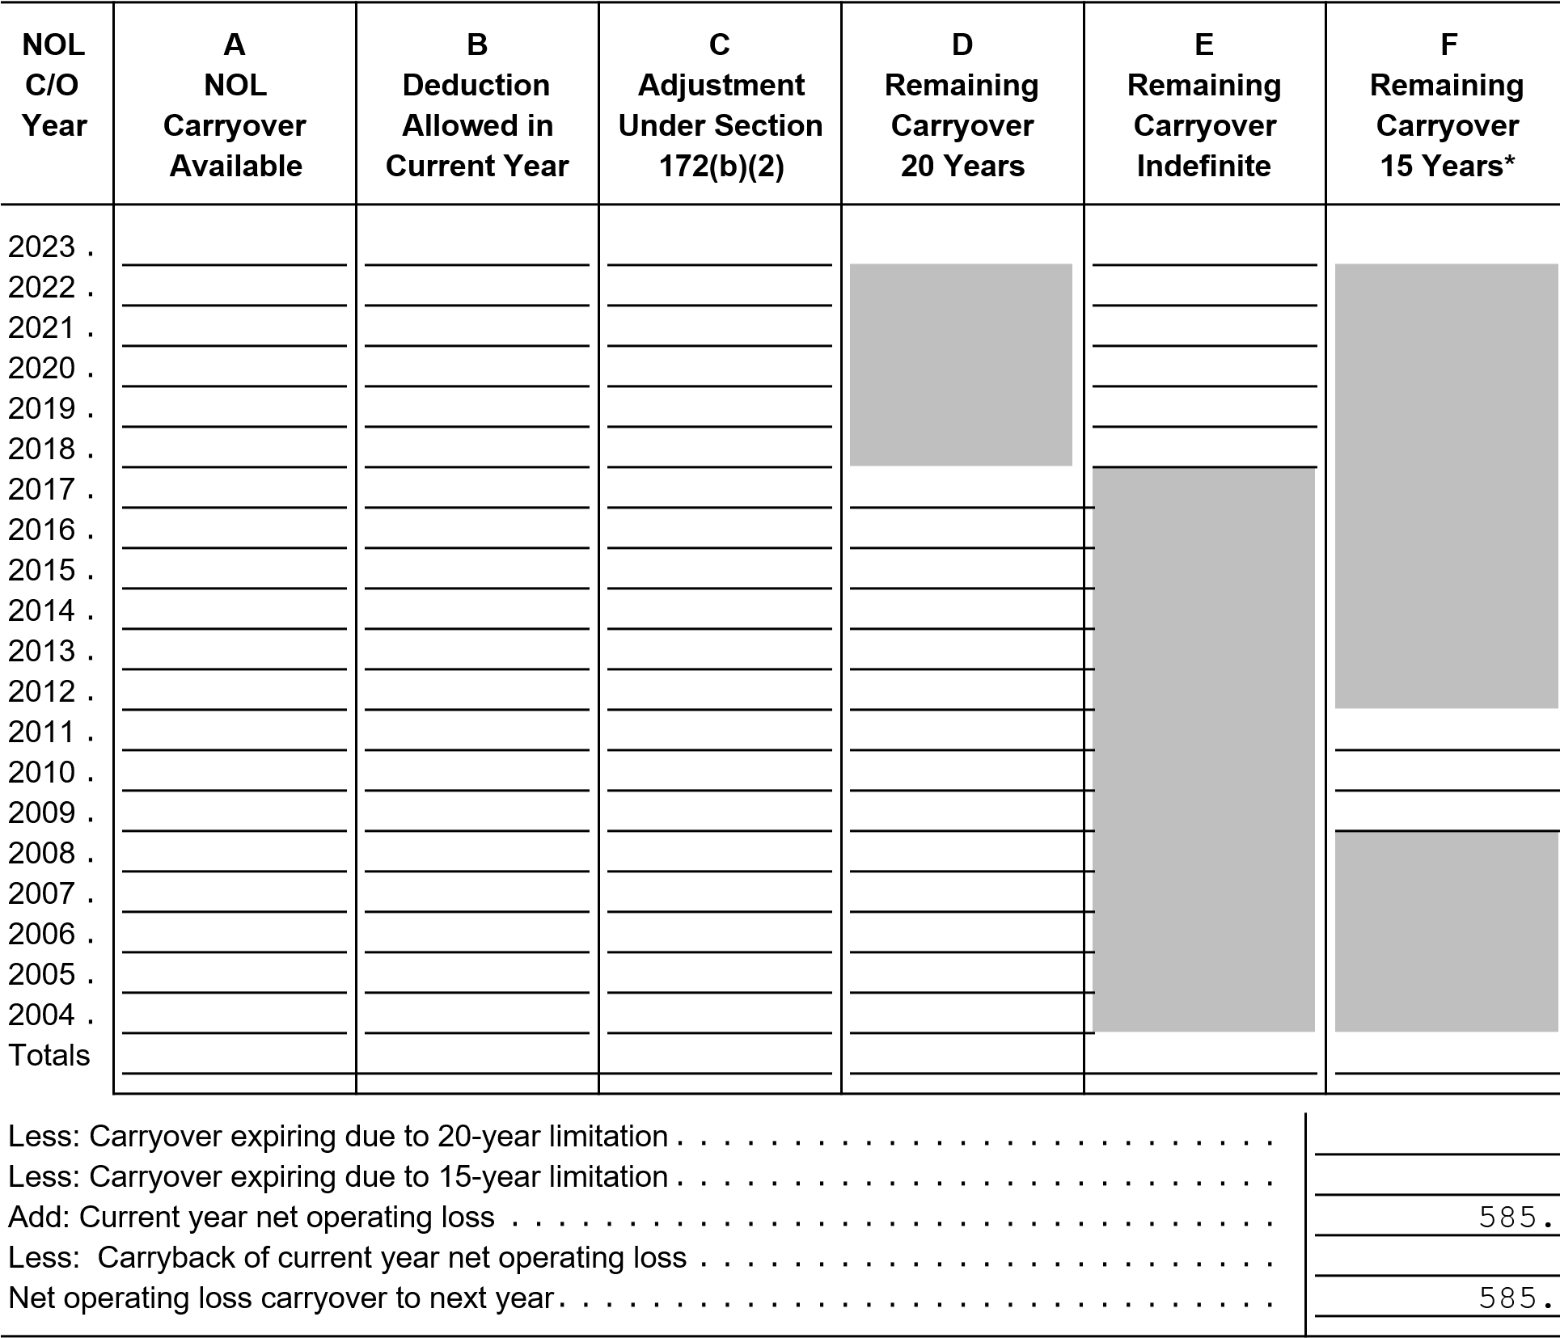
HSE first 99-3214358 1

Additional Information From 2024 Federal Corporation Tax Return
Form 1120: US Corporation Income Tax Return
Schedule M-1, Line 5c Continuation Statement
Description |  | Amount
Cr small employer health ins prems from Form 8941 |  | 0.
 | Total | 0.

HSE first
INSTRUCTIONS FOR MAILING YOUR 2024 GEORGIA CORPORATION TAX RETURN
-------------------------------------------------------------------------------No payment is required with your Georgia Form 600.
Mail your return to the following address on or before April 15, 2025:
GEORGIA DEPARTMENT OF REVENUE
PROCESSING CENTER
P.O. BOX 740397
ATLANTA, GA 30374-0397 Be sure to have an officer of the corporation sign and date the return.
Attach the following to your return:
A complete copy of your federal return and supporting schedules.
Any necessary credit form(s) you are claiming on page 4 of Form 600.


2501401616
Georgia Form 600 ((Rev. 07/23/24) Page 1
Corporation Tax Return (Approved software version) Georgia Department of Revenue
2024 Income Tax Return
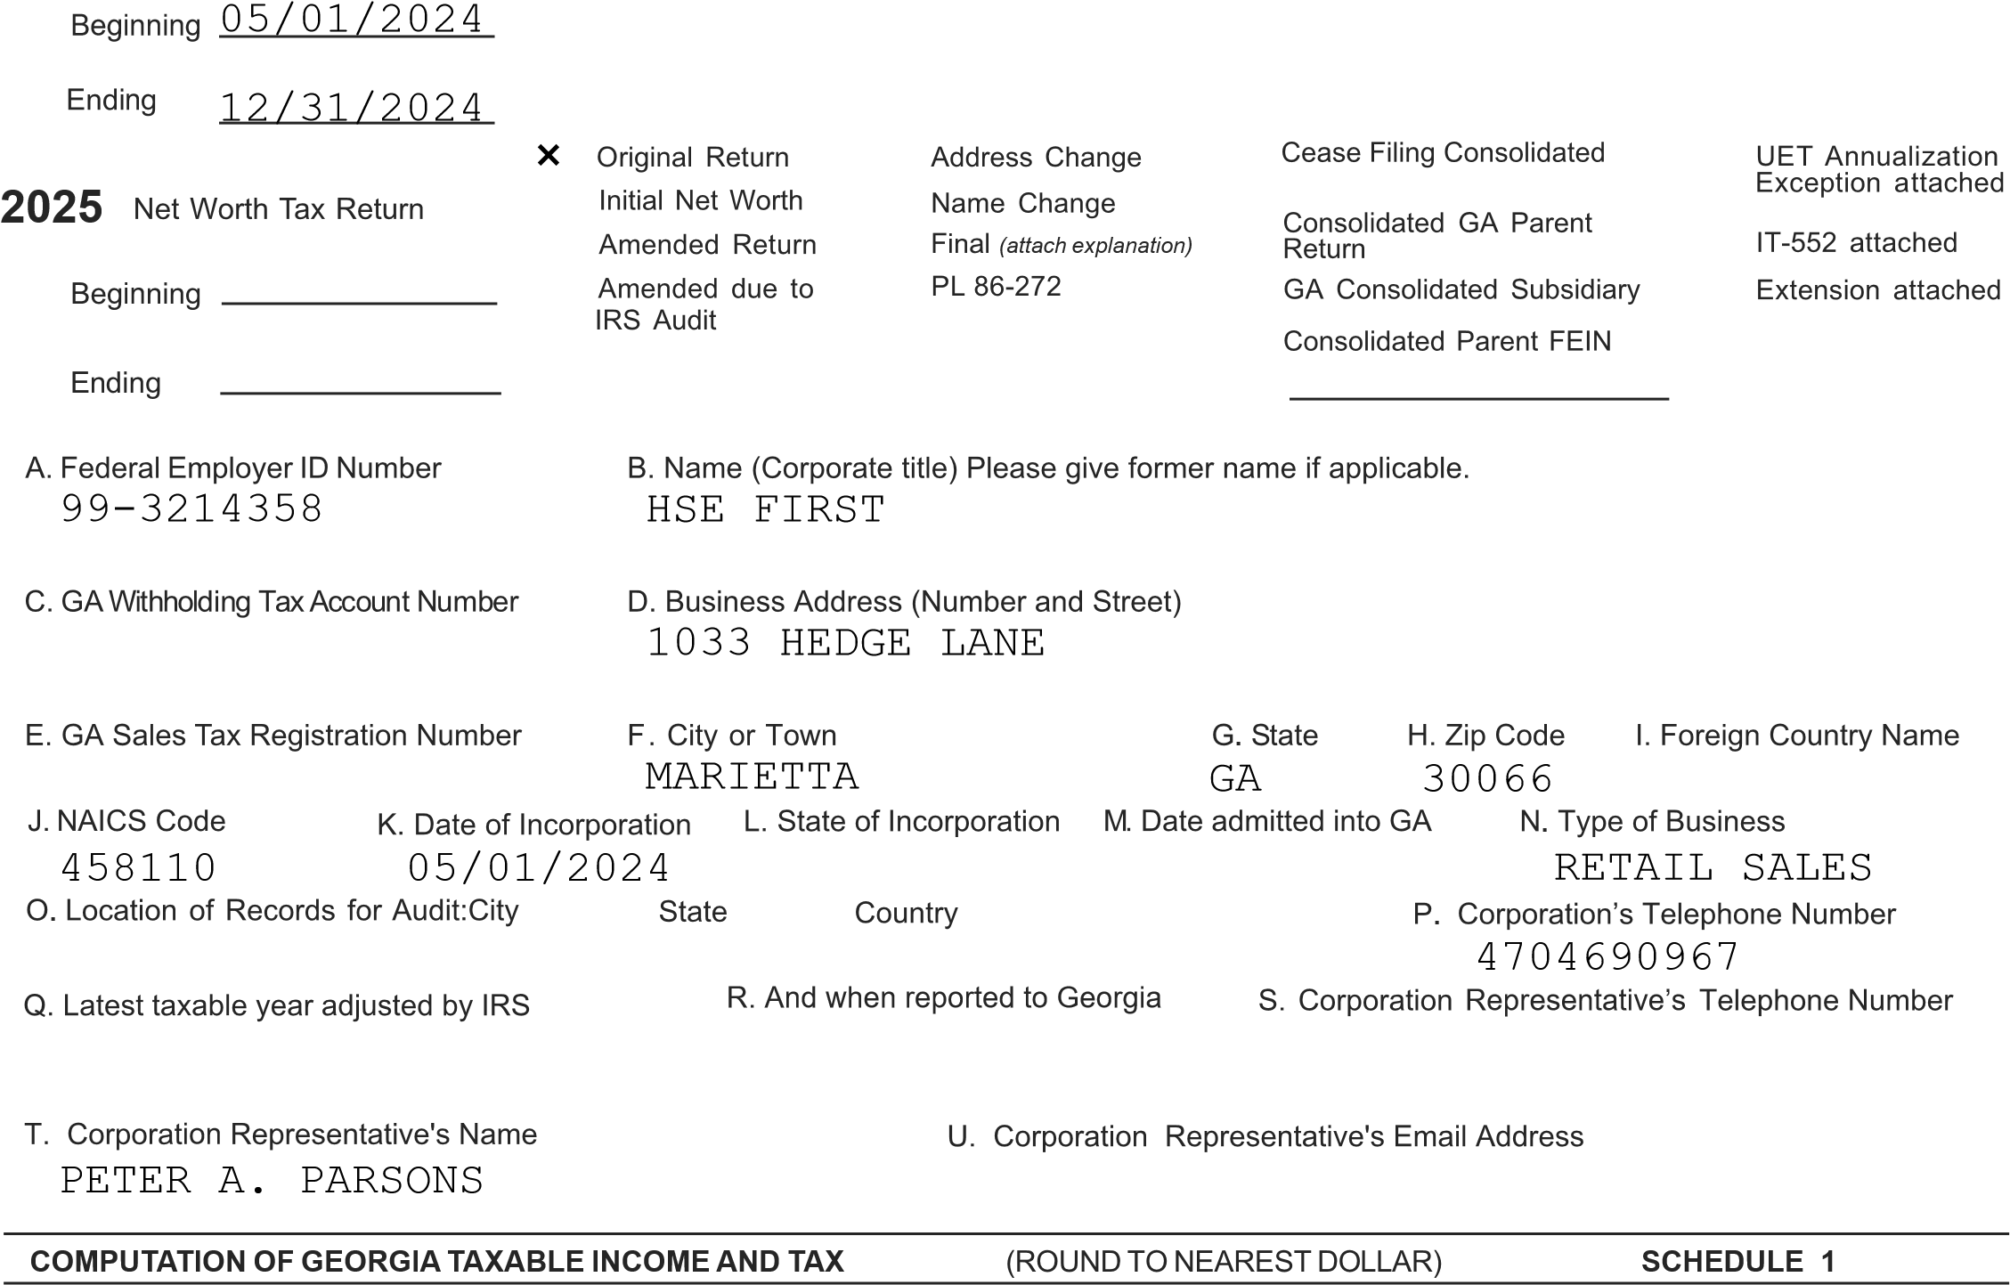
- Federal Taxable Income (Copy of Federal return and supporting schedules must be attached) ..... 1.  - Additions to Federal Income (from Schedule 4) ................................................................... 2.  - Total (add Lines 1 and 2 ) ...................................................................................................... 3.  - Subtractions from Federal Income (from Schedule 5) ......................................................... 4.  - Balance (Line 3 less Line 4) ................................................................................................. 5. 6. Georgia Net Operating loss deduction (from Schedule 9; See IT-611 instructions for 80% limitation) 6.  - Georgia Taxable Income (Line 5 less Line 6 or Schedule 7, Line 9)................................... 7.  - Passive Loss/Capital Loss Deduction (attach Schedule); See IT-611 instructions................. 8. 9. Georgia Taxable Income after Passive Loss/Capital Loss Deduction. (Line 7 less Line 8).... 9. | -585  -585  -585  -585  -585
10. Income Tax Line 9 x 5.39%).................................................................................................. 10. 0
COMPUTATION OF NET WORTH TAX SCHEDULE 2
- Total Capital stock issued.......................................................... ............................................  - Paid in or Capital surplus .....................................................................................................  - Total Retained earnings.......................................................................................................  - Net Worth (Total of Lines 1, 2, and 3).................................................................................... | - 0  - 0  - 0  - 0
(GA. and Dom. For. Corp.-100%) (Foreign Corp. - Line 4, Sch. 8)  - Net Worth Taxable by Georgia (Line 4 x Line 5) ....................................................................  - Net Worth Tax (from table in instructions)............................................................................. | - 0  - 0
5. Ratio .... 5. 1.000000
REV 12/09/24 TTBIZ
INTUIT 03 1030-016 2024 GA 014 T1 16
Georgia Form 600/2024

Page 2
(Corporation) Name  COMPUTATION OF TAX DUE OR OVERPAYMENT  1. Total Tax (Schedule 1, Line 10 and Schedule 2, Line 7) ..... | (ROUND TO NEAREST DOLLAR)  A. Income Tax B. Net Worth Tax  0 0 | FEIN99-3214358  SCHEDULE 3  C. Total 1. | 0
2501401626
- Credits and payments of estimated tax.................................
- Schedule 10* Credits (must be filed electronically)...............
- Withholding Credits (G2-A, G2-LP, and/or G2-RP)...............

- Schedule 10B Refundable tax credits (must be filed electronically )
- Balance of tax due (Line 1, less Lines 2, 3, 4, and 5)............ 0
11.

2.
3.
4.
5.
6.
7.
8.
9.
10.
11.
).............................................

- Amount of overpayment (Lines 2, 3, 4, and 5 less Line 1)....
- Interest due (See Instructions) ............................................ ..
- Form 600 UET (Estimated tax penalty) ................................
- Other penalty due (See Instructions) ....................................
0
12. Amount to be credited to 2025 estimated tax (Line 7 less Lines 8-10) Refund 12.
*NOTE: Any tax credits from Schedule 10 may be applied against income tax liability only, not net worth tax liability.
SEE PAGE 3 SIGNATURE SECTION FOR DIRECT DEPOSIT OPTIONS

ADDITIONS TO FEDERAL TAXABLE INCOME (ROUND TO NEAREST DOLLAR) SCHEDULE 4

- State and municipal bond interest (other than Georgia or political subdivision thereof) ........... 1.
- Net income or net profits taxes imposed by taxing jurisdictions other than Georgia................ 2. 3. Expense attributable to tax exempt income................................................................................ 3.
- Net operating loss deducted on Federal return.......................................................................... 4.
6. Intangible expenses and related interest cost ........................................................................... 6. 7. Captive REIT expenses and costs.............................................................................................. 7.
8. Other Additions (Attach Schedule)............................................................................................. 8. 9. TOTAL - Enter also on Line 2, Schedule 1 ................................................................................... 9.
SUBTRACTIONS FROM FEDERAL TAXABLE INCOME (ROUND TO NEAREST DOLLAR) | SCHEDULE 5
- Interest on obligations of United States (must be reduced by direct and indirect interest expense) 1.
- Exception to intangible expenses and related interest cost (Attach IT-Addback) .................. 2.
- Exception to captive REIT expenses and costs (Attach IT-REIT) ............................................ 3.
- Other Subtractions (Must Attach Schedule) ............................................................................. 4.
- TOTAL - Enter also on Line 4, Schedule 1.................................................................................. 5.
APPORTIONMENT OF INCOME | SCHEDULE 6
- Reserved 5.
A. WITHIN GEORGIA B. EVERYWHERE C. DO NOT ROUND
COL (A) / COL (B)
COMPUTE TO SIX DECIMALS
- Gross receipts from business.................................... 1.
- Georgia Ratio (Divide Column A by Column B)............ 2.
COMPUTATION OF GEORGIA NET INCOME (ROUND TO NEAREST DOLLAR) | SCHEDULE 7
- Net business income (Schedule 1, Line 5)................................................................................ 1.
- Income allocated everywhere (Must Attach Schedule)............................................................ 2.
- Business income subject to apportionment (Line 1 less Line 2) .............................................. 3.
4. Georgia Ratio (Schedule 6, Column C) ................................. 4.
5. Net business income apportioned to Georgia (Line 3 x Line 4)................................................ | 5.
6. Net income allocated to Georgia (Attach Schedule) ................................................................. | 6.
7. Total of Lines 5 and 6................................................................................................................. | 7.
8. Less: Net operating loss apportioned to GA (from Schedule 9, see IT-611 80% instructions) ...... | 8.
9. Georgia taxable income (Enter also on Schedule 1, Line 7)..................................................... | 9.
REV 12/09/24 TTBIZ

Page 3
2501401636
(Corporation) Name | FEIN 99-3214358
COMPUTATION OF GEORGIA NET WORTH RATIO | (TO BE USED BY FOREIGN CORPS ONLY) SCHEDULE 8
C. GA Ratio (A/B)
- Total value of property owned (Total assets from Federal balance sheet) 1.
A. WITHIN GEORGIA
B. TOTAL EVERYWHERE
DO NOT ROUND
COMPUTE TO SIX DECIMALS

- Gross receipts from business ....................................................... 2.

- Totals (Line 1 plus Line 2)............................................................... 3. 4. Georgia Ratio (Divide Line 3A by 3B)................................................ 4.

A copy of the Federal Return and supporting Schedules must be attached if filing by paper. No extension of time for filing will be allowed unless a copy of the request for a Federal extension or Form IT-303 is attached to this return.
Make check payable to: Georgia Department of Revenue
Mail to: Georgia Department of Revenue, Processing Center, P O Box 740397, Atlanta, Georgia 30374-0397

DIRECT DEPOSIT OPTIONS

A. Direct Deposit (For U.S. Accounts Only) See booklet for further instructions. If Direct Deposit is not selected, a paper check will be issued.
Routing Type: Checking Savings Number
Account
Number

Declaration: I/We declare under the penalties of perjury that I/we have examined this return (including accompanying schedules and statements) and to the best of my/our knowledge and belief, it is true, correct, and complete. If prepared by a person other than the taxpayer, this declaration is based on all information of which the preparer has knowledge.
By providing my e-mail address I am authorizing the Georgia Department of Revenue to electronically notify me at the below e-mail address regarding any updates to my account(s).
Taxpayer’s E-mail Address:
Check the box to authorize the Georgia Department of Revenue to discuss the contents of this tax return with the named preparer.

SELF-PREPARED
SIGNATURE OF OFFICER SIGNATURE OF INDIVIDUAL OR FIRM PREPARING THE RETURN

TITLE FIRM PREPARING THE RETURN

04/15/2025

DATE PREPARER’S PHONE NUMBER

PREPARER’S FEIN/S SN/PTIN

INTUIT 03 1030-016 2024 GA 014 T1 16
REV 12/09/24 TTBIZ

4
o

Page 4
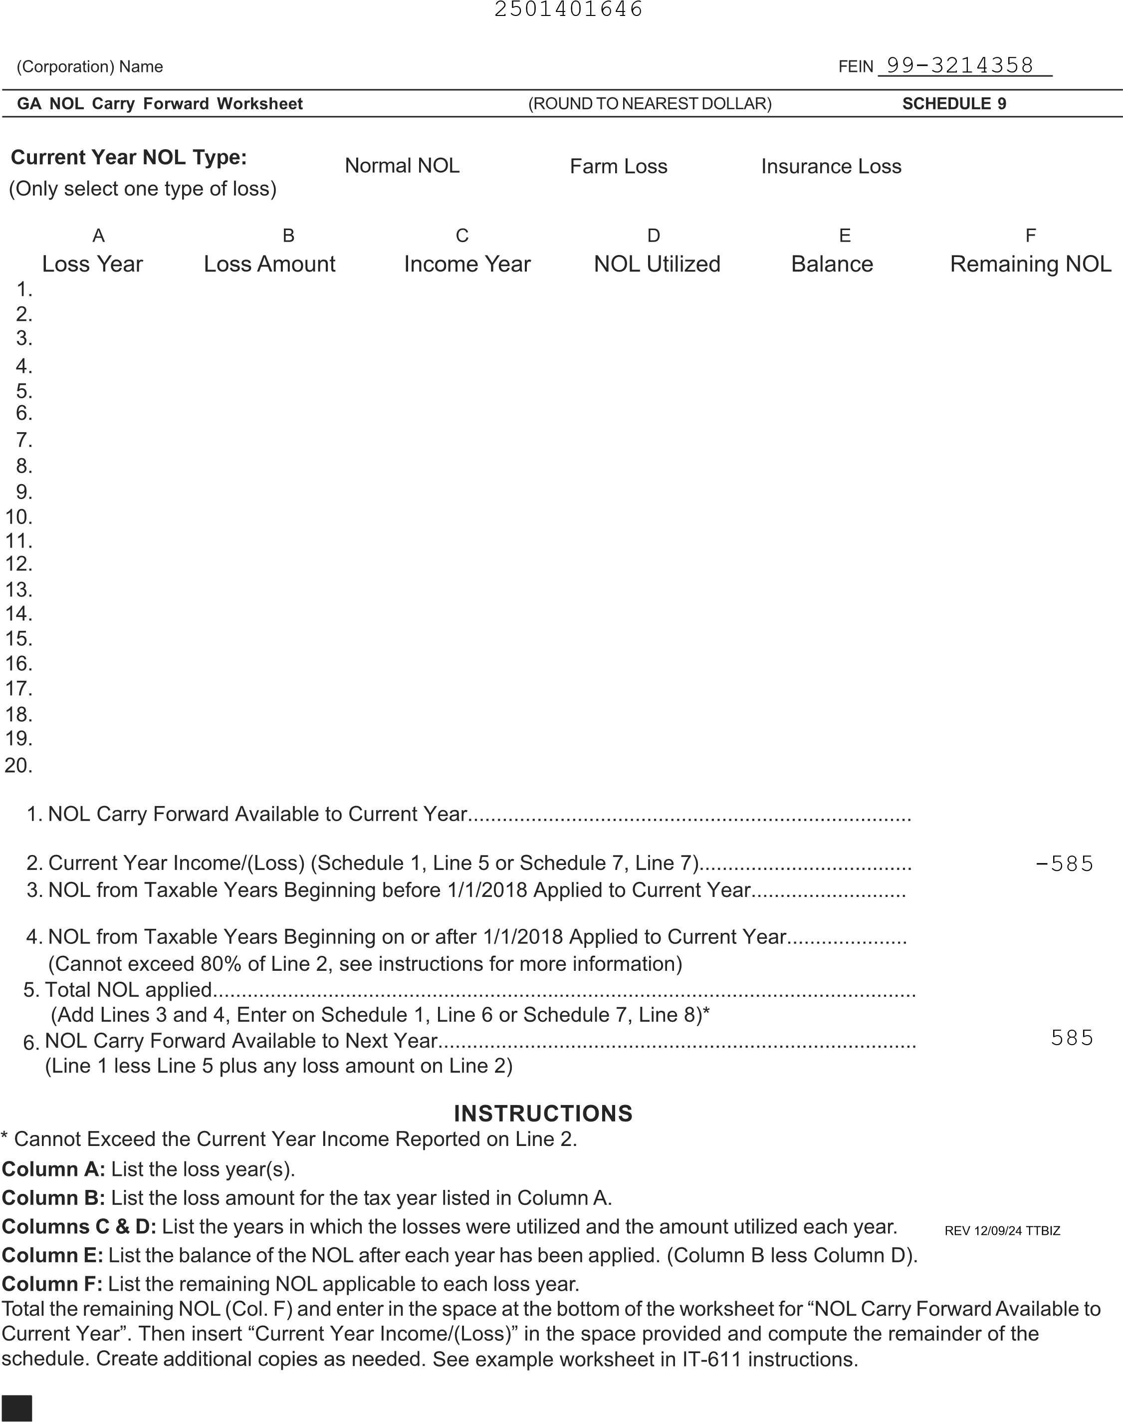

Page 5
2501401656
(Corporation) Name |  | FEIN99-3214358
CREDIT USAGE AND CARRYOVER | (ROUND TO NEAREST DOLLAR) | SCHEDULE 10
- Complete a separate schedule for each Credit Code.
- Total the amounts on Line 13 of each schedule and enter the total on the credit line of the return.
- If there is a credit eligible for carryover to this tax year, please complete a schedule even if the credit is not used for this tax year.
- See the tax booklet for a list of credit codes.
- See the relevant forms, statutes, and regulations to determine how the credit is allocated to the owners, to determine when carryoversexpire, and to see if the credit is limited to a certain percentage of tax.
- If the credit for a particular credit code originated with more than one person or company, enter separate information on Lines 3 through 9 below.
- The credit certificate number is issued by the Department of Revenue for credits that are preapproved. If applicable, please enter the Departmentof Revenue credit certificate number where indicated.
- Before the Line 14 carryover is applied to the next tax year, the amount must be reduced by any amounts elected to be applied to withholding forthis tax year and by any carryovers that have expired.
For the credit generated this tax year, list the Company Name, ID number, and Credit Certificate number if applicable. Purchased credits and credits received from an assignment should also be included. If the credit originated with this taxpayer, enter this taxpayer’s name and ID# below.
- Credit Code
- Credit remaining from previous years (do not include amounts elected to be applied towithholding)
- Company Name ID Number
Credit Certificate # Credit Generated
this Tax Year
- Company Name ID Number
Credit Certificate # Credit Generated
CREDITS MUST BE FILED ELECTRONICALLY
CREDITS MUST BE FILED ELECTRONICALLY
this Tax Year
- Company Name ID Number
Credit Certificate # Credit Generated
this Tax Year
- Company Name ID Number
Credit Certificate # Credit Generated
this Tax Year
- Company Name ID Number
Credit Certificate # Credit Generated
this Tax Year
- Company Name ID Number
Credit Certificate # Credit Generated
this Tax Year
- Company Name ID Number
Credit Certificate # Credit Generated
this Tax Year
- Total availabl e credit for this tax year (sum of Lines 2 through 9) ¹ ^{0.}
- Enter the amount assigned to affiliated entities (see Schedule 11) 11.
12 . Enter the amount of the credit sold (only certain credits can be sold; see instructions ) 12.
13. Credit used for this tax year (enter here and on Schedule 3, Line 3) 13. 14. Potential carryover to next tax year (Line 10 less Lines 11,12, and 13) 14.
REV 12/09/24 TTBIZ

Page 6 SCHEDULE 10B 2501401666
(Corporation) Name HSE FIRST FEIN 99-3214358

REFUNDABLE TAX CREDITS (ROUND TO NEAREST DOLLAR) SCHEDULE 10B

- Complete a separate schedule for each Credit Code.
- Total the amounts on Line 13 of each schedule and enter the total on the credit line of the return.
- If there is a credit eligible for carryover to this tax year, please complete a schedule even if the credit is not used for this tax year.
- See the tax booklet for a list of credit codes.
- See the relevant forms, statutes, and regulations to determine how the credit is allocated to the owners and, to determine when carryovers expire.
- If the credit for a particular credit code originated with more than one person or company, enter separate information on Lines 3 through 9 below.
- The credit certificate number is issued by the Department of Revenue for credits that are preapproved. If applicable, please enter the Departmentof Revenue credit certificate number where indicated.
- Before the Line 14 carryover is applied to the next tax year, the amount must be reduced by any amounts elected to be applied to withholding forthis tax year and by any carryovers that have expired.
For the credit generated this tax year, list the Company Name, ID number, and Credit Certificate number if applicable. Purchased credits and credits received from an assignment should also be included. If the credit originated with this taxpayer, enter this taxpayer’s name and ID# below.
Note: A purchased Timber Tax Credit is not a refundable tax credit. Use Schedule 10 if the Timber Tax Credit was purchased.
- Credit Code
- Credit remaining from previous years (do not include amounts elected to be applied towithholding)
CREDITS MUST BE FILED ELECTRONICALLY
CREDITS MUST BE FILED ELECTRONICALLY
- Company Name  Credit Certificate #  - Company Name  Credit Certificate #  - Company Name  Credit Certificate #  - Company Name  Credit Certificate #  - Company Name  Credit Certificate #  - Company Name  Credit Certificate #  - Company Name  Credit Certificate #  - Total availabl e credit for this tax year (sum of Lines 2 through 9)  - Enter the amount assigned to affiliated entities (see Schedule 11) | ID Number  Credit Generated this Tax Year  ID Number  Credit Generated this Tax Year  ID Number  Credit Generated this Tax Year  ID Number  Credit Generated this Tax Year  ID Number  Credit Generated this Tax Year  ID Number  Credit Generated this Tax Year  ID Number  Credit Generated this Tax Year  ¹ ^{0.}  11.
12 . Enter the amount of the credit sold (only certain credits can be sold; see instructions ) 12.
13. Credit used for this tax year (enter here and on Schedule 3, Line 5) 13. 14. Potential carryover to next tax year (Line 10 less Lines 11,12, and 13) 14.
REV 12/09/24 TTBIZ

Page 7
2501401676
(Corporation) Name HSE FIRST FEIN99-3214358
ASSIGNED TAX CREDITS (ROUND TO NEAREST DOLLAR) SCHEDULE 11
Georgia Code Section 48-7-42 provides that in lieu of claiming any Georgia income tax credit for which a taxpayer otherwise is eligible for the taxable year, the taxpayer may elect to assign credits in whole or in part to one or more “affiliated entities”. The term “affiliated entities” is defined as:
- A corporation that is a member of the taxpayer’s affiliated group within the meaning of Section 1504(a) of the Internal Revenue Code; or
- An entity affiliated with a corporation, business, partnership, or limited liability company taxpayer, which entity:
  - Owns or leases the land on which a project is constructed;
  - Provides capital for construction of the project; and
  - Is the grantor or owner under a management agreement with a managing company for the project.
No carryover attributable to the unused portion of any previously claimed or assigned credit may be assigned or reassigned, except if the assignor and the recipient of an assigned tax credit cease to be affiliated entities, then any carryover attributable to the unused portion of the credit is transferred back to the assignor of the credit. The assignor is permitted to use any such carryover and also shall be permitted to assign the carryover to one or more affiliated entities, as if such carryover were an income tax credit for which the assignor became eligible in the taxable year in which the carryover was transferred back to the assignor. In the case of any credit that must be claimed in installments in more than one taxable year, the election under this subsection may be made on an annual basis with respect to each such installment. For additional information, please refer to Georgia Code Section 48-7-42.
If the corporation filing this return is assigning tax credits to other affiliates, please provide detail below specifying where the tax credits are being assigned.
1.
2.
3.
4.
5.
6.
7.
8.
CREDITS MUST BE FILED ELECTRONICALLY
CREDITS MUST BE FILED ELECTRONICALLY
All assignments of credits must be made before the statutory due date of the return (including extensions) per O.C.G.A. § 48-7-42 (b).
Credit Code Corporation Name FEIN Amount of Credit Credit Certificate #
(if applicable )
1.
2.
3.
4.
5.
6.
7.
8.
REV 12/09/24 TTBIZ
Page 8
2501401686
(Corporation) Name HSE FIRST FEIN 99-3214358
SCHEDULE
All members (Parent and Subsidiaries) included in the Georgia consolidated group must be listed.
Enter the Georgia Parent corporation on Line 1. List the subsidiary members included in the consolidated group on the
remaining lines.
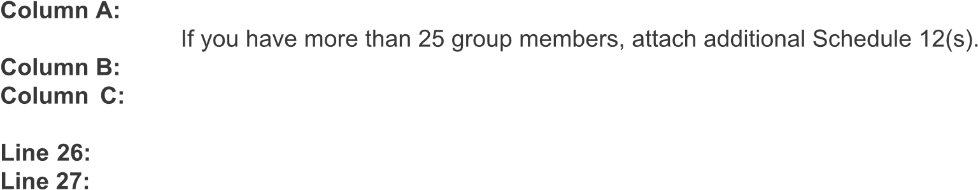
Enter the Federal Employer Identification Number (FEIN) for each member in the consolidated group.
Enter the Net Worth tax amount listed on Schedule 2, Line 7 for each member in the Georgia group, including
the Parent corporation.
Enter the total Net Worth tax from all additional Schedule 12(s).
Add lines 1 through 26. Enter the total Net Worth Tax and enter this amount on Schedule 3, Line 1B.
A B C
Nam FEIN Net Worth Tax
1.
2.
3.
4.
5.
6.
7.
8.
9.
10.
11.
12.
13.
14.
15.
16.
17.
18.
19.
20.
21.
22.
23.
24. 25.
- Enter total Net Worth Tax from all Additional Schedule 12(s).......................... 26.
- Total Net Worth Tax , add lines 1 through 26.
(Enter on Schedule 3, Line 1B) ....................................................................... 27.

For Paperwork Reduction Act Notice, see separate instructions. REV 03/21/25 TTBIZ ^{Form} 1120 (2024)
BAA

Schedule C | Dividends, Inclusions, and Special Deductions (see instructions) | (a) Dividends and inclusions | (b) % | (c) Special deductions  (a) × (b)
- Dividends from less-than-20%-owned domestic corporations (other than debt-financed stock) . . . . . . . . . . . . . . . . . . . . . . . .  - Dividends from 20%-or-more-owned domestic corporations (other than debt-financed stock) . . . . . . . . . . . . . . . . . . . . . . . .  - Dividends on certain debt-financed stock of domestic and foreign corporations . .  - Dividends on certain preferred stock of less-than-20%-owned public utilities . . .  - Dividends on certain preferred stock of 20%-or-more-owned public utilities . . . .  - Dividends from less-than-20%-owned foreign corporations and certain FSCs . . .  - Dividends from 20%-or-more-owned foreign corporations and certain FSCs . . .  - Dividends from wholly owned foreign subsidiaries . . . . . . . . . . .  - Subtotal. Add lines 1 through 8. See instructions for limitations . . . . . . .  - Dividends from domestic corporations received by a small business investment company operating under the Small Business Investment Act of 1958 . . . . .  - Dividends from affiliated group members . . . . . . . . . . . . . .  - Dividends from certain FSCs . . . . . . . . . . . . . . . . .  - Foreign-source portion of dividends received from a specified 10%-owned foreign corporation (excluding hybrid dividends) (see instructions) . . . . . . . . .  - Dividends from foreign corporations not included on line 3, 6, 7, 8, 11, 12, or 13  (including any hybrid dividends) . . . . . . . . . . . . . . . . .  - Reserved for future use . . . . . . . . . . . . . . . . . . .  16a Subpart F inclusions derived from the sale by a controlled foreign corporation (CFC) of the stock of a lower-tier foreign corporation treated as a dividend (attach Form(s) 5471)  (see instructions) . . . . . . . . . . . . . . . . . . . . .  - Subpart F inclusions derived from hybrid dividends of tiered corporations (attach Form(s)  5471) (see instructions) . . . . . . . . . . . . . . . . . . .  - Other inclusions from CFCs under subpart F not included on line 16a, 16b, or 17 (attach  Form(s) 5471) (see instructions) . . . . . . . . . . . . . . . . .  - Global Intangible Low-Taxed Income (GILTI) (attach Form(s) 5471 and Form 8992) . .  - Gross-up for foreign taxes deemed paid . . . . . . . . . . . . . .  - IC-DISC and former DISC dividends not included on line 1, 2, or 3 . . . . . .  - Other dividends . . . . . . . . . . . . . . . . . . . . .  - Deduction for dividends paid on certain preferred stock of public utilities . . . .  - Section 250 deduction (attach Form 8993) . . . . . . . . . . . . .  - Total dividends and inclusions. Add column (a), lines 9 through 20. Enter here and on page 1, line 4 . . . . . . . . . . . . . . . . . . . . . .  - Total special deductions. Add column (c), lines 9 through 22. Enter here and on page 1, line 29b |  |  | 50
 |  |  | 65
 |  |  | See instructions
 |  |  | 23.3
 |  |  | 26.7
 |  |  | 50
 |  |  | 65
 |  |  | 100
 |  |  | See instructions
 |  |  | 100
 |  |  | 100
 |  |  | 100
 |  |  | 100
 |  |  | 100
 |  | . . . . . . .
REV 03/21/25 TTBIZ Form 1120 (2024)
Schedule J | Tax Computation and Payment (see instructions)
- a Income tax (see instructions) . . . . . . . . . . . . . . . . . . b Tax from Form 1120-L (see instructions) . . . . . . . . . . . . . . c Section 1291 tax from Form 8621 . . . . . . . . . . . . . . . . d Tax adjustment from Form 8978 . . . . . . . . . . . . . . . . . e Additional tax under section 197(f) . . . . . . . . . . . . . . . . f Base erosion minimum tax from Form 8991 . . . . . . . . . . . . . g Amount from Form 4255, Part I, line 3, column (q) . . . . . . . . . . . z Other chapter 1 tax . . . . . . . . . . . . . . . . . . . .  - Total income tax. Add lines 1a through 1z . . . . . . . . . . . . . . .  - Corporate alternative minimum tax from Form 4626, Part II, line 13 (attach Form 4626). .  - Add lines 2 and 3 . . . . . . . . . . . . . . . . . . . . . .  - a Foreign tax credit (attach Form 1118) . . . . . . . . . . . . . . . b Credit from Form 8834 (see instructions) . . . . . . . . . . . . . . c General business credit (see instructions—attach Form 3800) . . . . . . . . d Credit for prior year minimum tax (attach Form 8827) . . . . . . . . . . e Bond credits from Form 8912 . . . . . . . . . . . . . . . . .  f Adjustment from Form 8978 . . . . . . . . . . . . . . . . . .  - Total credits. Add lines 5a through 5f . . . . . . . . . . . . . . . .  - Subtract line 6 from line 4 . . . . . . . . . . . . . . . . . . .  - Personal holding company tax (attach Schedule PH (Form 1120)) . . . . . . . .  - a Amount from Form 4255, Part I, line 3, column (r) . . . . . . . . . . . b Recapture of low-income housing credit (attach Form 8611) . . . . . . . . c Completed long-term contract look-back interest due (attach Form 8697) . . . . d Interest due under the look-back method—income forecast method (attach Form 8866) e Alternative tax on qualifying shipping activities (attach Form 8902) . . . . . . f Interest/tax due under section 453A(c) . . . . . . . . . . . . . . . g Interest/tax due under section 453(l) . . . . . . . . . . . . . . .  z Other (see instructions—attach statement) . . . . . . . . . . . . .  - Total. Add lines 9a through 9z . . . . . . . . . . . . . . . . . .  - a Total tax before deferred taxes. Add lines 7, 8, and 10 . . . . . . . . . .  b Deferred tax on the corporation's share of undistributed earnings of a qualified electing fund . . . . . . . . . . . . . . . . . . . . . . . . . c Deferred LIFO recapture tax (section 1363(d)) . . . . . . . . . . . .  - Total tax. Subtract the sum of lines 11b and 11c from 11a. Enter here and on page 1, line  - Preceding year’s overpayment credited to the current year . . . . . . . . . .  - Current year’s estimated tax payments . . . . . . . . . . . . . . .  - Current year’s refund applied for on Form 4466 . . . . . . . . . . . . .  - Reserved for future use . . . . . . . . . . . . . . . . . . . .  - Tax deposited with Form 7004 . . . . . . . . . . . . . . . . . .  - Withholding (see instructions) . . . . . . . . . . . . . . . . . .  - Total payments. Combine lines 13 through 18 . . . . . . . . . . . . .  - Refundable credits from: a Form 2439 . . . . . . . . . . . . . . . . . . . . . . . b Form 4136 . . . . . . . . . . . . . . . . . . . . . . .  c Credit for tax withheld under chapter 3 or 4 from Form 1042-S, Form 8805, or Form  8288 (attach the applicable form) . . . . . . . . . . . . . . . . z Other (attach statement—see instructions) . . . . . . . . . . . . .  - Total credits. Add lines 20a through 20z . . . . . . . . . . . . . . .  - Elective payment election amount from Form 3800 . . . . . . . . . . . .  - Total payments and credits. Add lines 19, 21, and 22. Enter here and on page 1, line 33. |  | 1a |  |  |  |  | 0 |  | 0
 |  | 1b |  |  |  |  |  |  | 0
 |  | 1c |  |  |  |  |  |  | 0
 |  | 1d |  |  |  |  |  |  | 0
 |  | 1e |  |  |  |  |  |  | 0
 |  | 1f |  |  |  |  |  |  | 0
 |  | 1g |  |  |  |  |  |  | 0
 |  | 1z |  |  |  |  |  |  | 0
 |  | . .  . .  . .  5a | .  .  . | .  .  . | .  .  . | .  .  . | .  .  . | 2 | 0
 |  |  |  |  |  |  |  | 3
 |  |  |  |  |  |  |  | 4 | 0
 |  | 5b
 |  | 5c
 |  | 5d
 |  | 5e
 |  | 5f
 |  | . .  . .  . .  9a | .  .  . | .  .  . | .  .  . | .  .  . | .  .  . | 6
 |  |  |  |  |  |  |  | 7 | 0
 |  |  |  |  |  |  |  | 8
 |  | 9b
 |  | 9c
 |  | 9d
 |  | 9e
 |  | 9f
 |  | 9g
 |  | 9z
 |  | . .  11a | . | . | . | . | .  0 | 10
 |  |  |  |  |  |  |  |  | 0
 |  | 11b |  |  |  |  |  |  | 0
 |  | 11c |  |  |  |  |  |  | 0
 |  | 31 . .  . .  . .  . .  . .  . .  . .  . .  20a | .  .  .  .  .  .  .  . | .  .  .  .  .  .  .  . | .  .  .  .  .  .  .  . | .  .  .  .  .  .  .  . | .  .  .  .  .  .  .  . | 12 | 0
 |  |  |  |  |  |  |  | 13
 |  |  |  |  |  |  |  | 14 | 0
 |  |  |  |  |  |  |  | 15 | ( )
 |  |  |  |  |  |  |  | 16
 |  |  |  |  |  |  |  | 17
 |  |  |  |  |  |  |  | 18
 |  |  |  |  |  |  |  | 19 | 0
 |  | 20b
 |  | 20c
 |  | 20z
 |  | . .  . .  . . | .  .  . | .  .  . | .  .  . | .  .  . | .  .  . | 21
 |  |  |  |  |  |  |  | 22
 |  |  |  |  |  |  |  | 23 | 0
REV 03/21/25 TTBIZ ^{Form} 1120 (2024)
REV 03/21/25 TTBIZ
Schedule K | Other Information (continued from page 4)
- Are the corporation’s total receipts (page 1, line 1a, plus lines 4 through 10) for the tax year and its total assets at the end of the tax year less than $250,000? . . . . . . . . . . . . . . . . . . . . . . . . . . . .  If “Yes,” the corporation is not required to complete Schedules L, M-1, and M-2. Instead, enter the total amount of cash distributions and the book value of property distributions (other than cash) made during this tax year $0.  - Is the corporation required to file Schedule UTP (Form 1120), Uncertain Tax Position Statement? See instructions . . . .  If “Yes,” complete and attach Schedule UTP.  15a Did the corporation make any payments that would require it to file Form(s) 1099? . . . . . . . . . . . . . . b If “Yes,” did or will the corporation file required Form(s) 1099? . . . . . . . . . . . . . . . . . . . .  - During this tax year, did the corporation have an 80%-or-more change in ownership, including a change due to redemption of its own stock? . . . . . . . . . . . . . . . . . . . . . . . . . . . . . . . . . .  - During or subsequent to this tax year, but before the filing of this return, did the corporation dispose of more than 65% (by value) of its assets in a taxable, non-taxable, or tax deferred transaction? . . . . . . . . . . . . . . . .  - Did this corporation receive assets in a section 351 transfer in which any of the transferred assets had a fair market basis or fair market value of more than $1 million? . . . . . . . . . . . . . . . . . . . . . . . . . .  - During this corporation’s tax year, did the corporation make any payments that would require it to file Forms 1042 and 1042-S under chapter 3 (sections 1441 through 1464) or chapter 4 (sections 1471 through 1474) of the Code? . . . . . . . .  - Is the corporation operating on a cooperative basis? . . . . . . . . . . . . . . . . . . . . . .  - During this tax year, did the corporation pay or accrue any interest or royalty for which the deduction is not allowed under section 267A? See instructions . . . . . . . . . . . . . . . . . . . . . . . . . . . . .  If “Yes,” enter the total amount of the disallowed deductions $  - Does this corporation have gross receipts of at least $500 million in any of the 3 preceding tax years? (See sections 59A(e)(2) and (3).) If “Yes,” complete and attach Form 8991.  - Did the corporation have an election under section 163(j) for any real property trade or business or any farming business in effect during this tax year? See instructions . . . . . . . . . . . . . . . . . . . . . . . . .  - Does the corporation satisfy one or more of the following? If “Yes,” complete and attach Form 8990. See instructions . . . a The corporation owns a pass-through entity with current, or prior year carryover, excess business interest expense.  - The corporation’s aggregate average annual gross receipts (determined under section 448(c)) for the 3 tax years preceding the current tax year are more than $30 million and the corporation has business interest expense.  - The corporation is a tax shelter and the corporation has business interest expense.  - Is the corporation attaching Form 8996 to certify as a Qualified Opportunity Fund? . . . . . . . . . . . . .  If “Yes,” enter amount from Form 8996, line 15 . . . . . . . . . . . $  - Since December 22, 2017, did a foreign corporation directly or indirectly acquire substantially all of the properties held directly or indirectly by the corporation, and was the ownership percentage (by vote or value) for purposes of section 7874 greater than  50% (for example, the shareholders held more than 50% of the stock of the foreign corporation)? If “Yes,” list the ownership percentage by vote and by value. See instructions . . . . . . . . . . . . . . . . . . . . . . .  Percentage: By Vote By Value  - At any time during this tax year, did the corporation (a) receive a digital asset (as a reward, award, or payment for property or services); or (b) sell, exchange, or otherwise dispose of a digital asset (or a financial interest in a digital asset)? See instructions .  - Is the corporation a member of a controlled group? . . . . . . . . . . . . . . . . . . . . . . .  If “Yes,” attach Schedule O (Form 1120). See instructions.  - Corporate Alternative Minimum Tax:  - Was the corporation an applicable corporation under section 59(k)(1) in any prior tax year? . . . . . . . . . . .  If “Yes,” go to question 29b. If “No,” skip to question 29c.  - Is the corporation an applicable corporation under section 59(k)(1) in the current tax year because the corporation was an applicable corporation in the prior tax year? . . . . . . . . . . . . . . . . . . . . . . . . .  If “Yes,” complete and attach Form 4626. If “No,” continue to question 29c.  - Does the corporation meet the requirements of the safe harbor method as provided under section 59(k)(3)(A) for the current tax year? See instructions . . . . . . . . . . . . . . . . . . . . . . . . . . . . . . .  If “No,” complete and attach Form 4626. If “Yes,” the corporation is not required to file Form 4626.  30 Is the corporation required to file Form 7208 relating to the excise tax on repurchase of corporate stock (see instructions):  a Under the rules for stock repurchased by a covered corporation (or stock acquired by its specified affiliate)? . . . . . . b Under the applicable foreign corporation rules? . . . . . . . . . . . . . . . . . . . . . . . . c Under the covered surrogate foreign corporation rules? . . . . . . . . . . . . . . . . . . . . . .  If “Yes” to either 30a, 30b, or 30c, complete Form 7208, Excise Tax on Repurchase of Corporate Stock. See the Instructions for Form 7208.  31 Is this a consolidated return with gross receipts or sales of $1 billion or more and a subchapter K basis adjustment, as described in the instructions, of $10 million or more? . . . . . . . . . . . . . . . . . . . . . .  If “Yes,” attach a statement. See instructions. |  | Yes | No
Form 1120 (2024)
REV 03/21/25 TTBIZ
Schedule L | Balance Sheets per Books |  | Beginning of tax year |  | End of tax year
Assets  1 Cash . . . . . . . . . . . .  2a Trade notes and accounts receivable . . . b Less allowance for bad debts . . . . .  - Inventories . . . . . . . . . . .  - U.S. government obligations . . . . .  - Tax-exempt securities (see instructions) . .  - Other current assets (attach statement) . .  - Loans to shareholders . . . . . . .  - Mortgage and real estate loans . . . . .  - Other investments (attach statement) . . . 10a Buildings and other depreciable assets . . b Less accumulated depreciation . . . . .  11a Depletable assets . . . . . . . . . b Less accumulated depletion . . . . . . 12 Land (net of any amortization) . . . . . 13a Intangible assets (amortizable only) . . . b Less accumulated amortization . . . . . 14 Other assets (attach statement) . . . . .  15 Total assets . . . . . . . . . . |  |  | (a) | (b) | (c) | (d)
 |  |  |  |  |  | 0.
 |  |  | ( ) |  | ( )
 |  |  |  |  |  | 400.
 |  |  |  |  | 0.
 |  |  | ( ) |  | ( 0. ) | 0.
 |  |  | ( ) |  | ( )
 |  |  |  |  |  | 0.
 |  |  |  |  | 0.
 |  |  | ( ) |  | ( 0. ) | 0.
 |  |  |  |  |  | 400.
Liabilities and Shareholders’ Equity
- Accounts payable . . . . . . . . .
- Mortgages, notes, bonds payable in less than 1 year 18 Other current liabilities (attach statement) . .
- Loans from shareholders . . . . . . .
- Mortgages, notes, bonds payable in 1 year or more 21 Other liabilities (attach statement) . . . .
22 Capital stock: a Preferred stock . . . .
b Common stock . . . . 23 Additional paid-in capital . . . . . . .
24 Retained earnings—Appropriated (attach statement) 25 Retained earnings—Unappropriated . . .
- Adjustments to shareholders’ equity (attach statement)
- Less cost of treasury stock . . . . . .
- Total liabilities and shareholders’ equity . .
 |  |  |  |  | 0.
 |  |  |  |  | 0. | 0.
 |  |  |  |  |  | 0.
 |  |  |  |  |  | 0.
 |  |  |  | ( ) |  | ( 0. )
 |  |  |  |  |  | 0.
Schedule M-1 |  | Reconciliation of Income (Loss) per Books With Income per Return
Note: The corporation may be required to file Schedule M-3. See instructions.
- Net income (loss) per books . . . . . .  - Federal income tax per books . . . . .  - Excess of capital losses over capital gains .  - Income subject to tax not recorded on books this year (itemize):  - Expenses recorded on books this year not deducted on this return (itemize): a Depreciation . . . . $ b Charitable contributions . $ c Travel and entertainment . $  See Statement  - Add lines 1 through 5 . . . . . . . . |  | 0. | - Income recorded on books this year not included on this return (itemize):  Tax-exempt interest $  - Deductions on this return not charged against book income this year (itemize):  a  Depreciation  .  .  $  b  Charitable contributions  $  - Add lines 7 and 8 . . . . . .  - Income (page 1, line 28)—line 6 less line 9
 |  | 0.
 |  | 0.
 |  | 0. |  | 0.
Schedule M-2 | Analysis of Unappropriated Retained Earnings per Books (Schedule L, Line 25)
- Balance at beginning of year . . . . .  - Net income (loss) per books . . . . . .  - Other increases (itemize):  - Add lines 1, 2, and 3 . . . . . . . . |  |  | - Distributions: a Cash . . . . .  b Stock . . . . c Property . . . .  - Other decreases (itemize):  - Add lines 5 and 6 . . . . . .  - Balance at end of year (line 4 less line 7)
 |  | 0.
 |  | 0. |  | 0.
REV 03/21/25 TTBIZ ^{Form} 1120 (2024)

Form 1125-A  (Rev. November 2024)  Department of the Treasury  Internal Revenue Service | Cost of Goods Sold  Attach to Form 1120, 1120-C, 1120-F, 1120S, or 1065.  Go to www.irs.gov/Form1125A for the latest information. |  |  | OMB No. 1545-0123
Name |  | Employer identification number
HSE first |  | 99-3214358
- Inventory at beginning of year . . . . . . . . . . . . . . . . . . . . . . . . .  - Purchases . . . . . . . . . . . . . . . . . . . . . . . . . . . . . . .  - Cost of labor . . . . . . . . . . . . . . . . . . . . . . . . . . . . . .  - Additional section 263A costs (attach schedule) . . . . . . . . . . . . . . . . . . . .  - Other costs (attach schedule) . . . . . . . . . . . . . . . . . . . . . . . . .  - Total. Add lines 1 through 5 . . . . . . . . . . . . . . . . . . . . . . . . . . 7 Inventory at end of year . . . . . . . . . . . . . . . . . . . . . . . . . . .  8 Cost of goods sold. Subtract line 7 from line 6. Enter here and on Form 1120, page 1, line 2, or the appropriate line of your tax return. See instructions . . . . . . . . . . . . . . . . . . . . . . |  |  | 1
 |  |  | 2 |  | 30
 |  |  | 3
 |  |  | 4
 |  |  | 5
 |  |  | 6 |  | 30
 |  |  | 7 |  | 400
 |  |  | 8 |  | -370
9a Check all methods used for valuing closing inventory. See instructions.
(i)Cost
(ii)Lower of cost or market
(iii)Other (specify method used and attach explanation)
For certain small business taxpayers, alternative methods of accounting for inventories:
(iv)Non-incidental materials and supplies method
(v)AFS method
(vi)Non-AFS method
9d(i)
9d(ii)
b Check if there was a writedown of subnormal goods . . . . . . . . . . . . . . . . . . . . . . . c Check if the LIFO inventory method was adopted this tax year for any goods (if checked, attach Form 970) . . . . . . . d (i) If the LIFO inventory method was used for this tax year, enter amount of closing inventory figured under LIFO (ii) If the LIFO inventory method was used for this tax year, enter amount of the closing LIFO Reserve . . . .
- If property is produced or acquired for resale, do the rules of section 263A apply to the entity? See instructions . . Yes No
- Was there any change in determining quantities, cost, or valuations between opening and closing inventory? If “Yes,”
attach explanation . . . . . . . . . . . . . . . . . . . . . . . . . . . . . Yes No

Section references are to the Internal Revenue Code unless otherwise noted.

What’s New
Small business taxpayers. For tax years beginning after December 31, 2023, if filing Form 1125-A for a small business taxpayer that uses an alternative method of accounting for inventories, check the applicable box on line 9a(iv) through 9a(vi). See the instructions for line 9.
General Instructions

Purpose of Form
Use Form 1125-A to figure and deduct cost of goods sold for certain entities.

Who Must File
Filers of Form 1120, 1120-C, 1120-F,
1120S, or 1065 must complete and attach Form 1125-A if the applicable entity reports a deduction for cost of goods sold.

Inventories
Generally, inventories are required at the beginning and end of each tax year if the production, purchase, or sale of merchandise is an income-producing factor. See Regulations section 1.471-1(a).
If inventories are required, you generally must use an accrual method of accounting for sales and purchases of inventory items.
Exception for small business taxpayers. A small business taxpayer can account for inventory by treating the inventory as non-incidental materials and supplies (line 9a(iv)), or conforming to its treatment of inventory in an applicable financial statement (as defined in section 451(b)(3)) (line 9a(v)). If it does not have an applicable financial statement, a small business taxpayer can use the method of accounting used in its books and records prepared according to its accounting procedures
(line 9a(vi)).
See the discussion on small business taxpayers in the instructions for your tax return. Also see sections 448(c) and 471(c).
For additional guidance on methods of accounting, see Pub. 538, Accounting Periods and Methods. For guidance on changing methods of accounting, see Form 3115, Application for Change in Accounting Method, and the Instructions for Form 3115.
Uniform capitalization rules. The uniform capitalization rules of section 263A generally require you to capitalize, or include in inventory, certain costs incurred in connection with the following.
- The production of real property and tangible personal property held in inventory or held for sale in the ordinary course of business.
- Real property or personal property (tangible and intangible) acquired for resale.
- The production of real property and tangible personal property for use in its trade or business or in an activity engaged in for profit.
A small business taxpayer is not required to capitalize costs under section 263A. See section 263A(i).
See the discussion on section 263A uniform capitalization rules in the instructions for your tax return before completing Form 1125-A. Also see Regulations sections 1.263A-1 through
1.263A-3. See Regulations section 1.263A-4 for rules for property produced in a farming business and Pub. 225, Farmer’s Tax Guide.

For Paperwork Reduction Act Notice, see instructions.BAA Cat. No. 55988R REV 03/21/25 TTBIZ ^{Form} 1125-A (Rev. 11-2024)
SCHEDULE G  (Form 1120)  (Rev. December 2011)  Department of the Treasury  Internal Revenue Service |  | Information on Certain Persons Owning the Corporation’s Voting Stock  a Attach to Form 1120. a See instructions on page 2. |  | OMB No. 1545-0123
Name |  |  | Employer identification number (EIN)
HSE first |  |  | 99-3214358
Part I | Certain Entities Owning the Corporation’s Voting Stock. (Form 1120, Schedule K, Question 4a). Complete
columns (i) through (v) below for any foreign or domestic corporation, partnership (including any entity treated as a partnership), trust, or tax-exempt organization that owns directly 20% or more, or owns, directly or indirectly, 50% or more of the total voting power of all classes of the corporation’s stock entitled to vote (see instructions).
Certain Individuals and Estates Owning the Corporation’s Voting Stock. (Form 1120, Schedule K, Question 4b). Complete columns (i) through (iv) below for any individual or estate that owns directly 20% or more, or owns, directly or indirectly, 50% or more of the total voting power of all classes of the corporation’s stock entitled to vote (see instructions).
i) Name of Entity
(
ii) Employer Identification
(
Number (if any)
iii) Type of Entity
(
iv) Country of Organization
(
v) Percentage Owned in Voting Stock
(
Part II
(i) Name of Individual or Estate | (ii) Identifying Number  (if any) | (iii) Country of  Citizenship (see instructions) | (iv) Percentage Owned in Voting Stock
Peter Parsons | 99-3214358 | US | 100
For Paperwork Reduction Act Notice, REV 03/21/25 TTBIZ Schedule G (Form 1120) (Rev. 12-2011) see the Instructions for Form 1120. BAA
HSE first 99-3214358 1

Additional Information From 2024 Federal Corporation Tax Return
Form 1120: US Corporation Income Tax Return
Schedule M-1, Line 5c Continuation Statement
Description |  | Amount
Cr small employer health ins prems from Form 8941 |  | 0.
 | Total | 0.

